Tom Riordan, Track and Trace
Purpose of report
For information.
Summary
Tom Riordan, Chief Executive of Leeds City Council, will give a presentation on the Government’s coronavirus (COVID-19) test and trace programme.

Recommendations
Members to note presentation and engage with discussion for details to take back to their authorities.

Next Steps
Members are encouraged to visit www.local.gov.uk/coronavirus-information-councils.

Contact officer: Paul Ogden
Position: Senior Adviser
Phone no: 02076643277
Email: Paul.Ogden@local.gov.uk

Tom Riordan
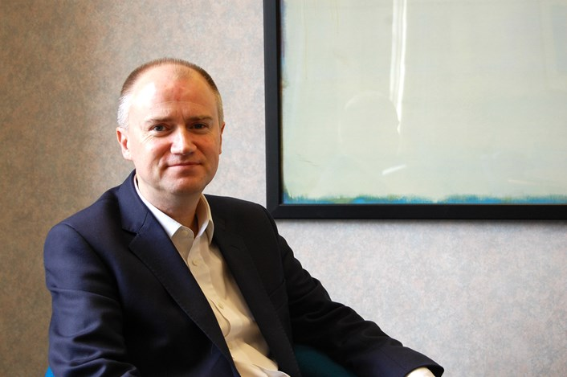
Biography
- Tom has been Chief Executive of Leeds City Council since 2010 and during this time has overseen £300m of efficiencies across the organisation and a significant transformation of the city, which is halfway through a £10bn investment pipeline. Plans are set to double the size and economic impact of the city centre through regeneration of the South Bank, one of the largest city centre regeneration and growth initiatives in Europe. Tom’s top priority is for the city’s growth to be inclusive with a key ambition of reducing health inequalities and improving the health of the poorest the fastest.

- In 2018, Tom led the regional bid that secured the new Channel 4 headquarters in Leeds bringing over 300 new jobs and unlocking growth in Yorkshire and the North East. Tom is leading the city’s participation in the Boston MIT global programme which will drive innovation and enterprise across the region, and played a key role in securing and running the 2014 Grand Depart of the Tour de France in Yorkshire.

- Tom has come full-circle from a North Yorkshire state education, via Oxford University, a Civil Service fast-stream career in international environmental policy and then leading the Regional Development Agency Yorkshire Forward.

- Leeds City Council won the MJ’s Council of the Year award in 2016 and was named Digital Council of the Year in the 2019 Digital Leaders 100 awards. For his commitment to the region, Tom was awarded Yorkshire Man of the Year 2017 and most recently CBE for services to local government in the 2020 New Year’s Honours. He is also a trustee on the Centre for Cities Board, and the Council's mental health champion.

- In May 2020, Tom was asked to take a key role on the NHS Test and Trace Programme, as the lead for outbreak planning to bring a local perspective to ensure that the work is community focused and effective.

