The Fair Funding Review and Business Rates Retention

Purpose of report
For discussion.

Summary
This paper provides a progress update on the Government’s Fair Funding Review and business rates retention reforms. It also sets out a draft LGA work plan on the Fair Funding Review.

Recommendation
That members of Executive provide comments on the paper, in particular the proposed additions to the LGA’s work plan on the Fair Funding Review in Appendix C.
Action
Officers to revise the work plan based on the discussion and to deliver against its objectives, overseen by the LGA Business Rates Task and Finish Group with regular updates to Leadership Board and Executive.

Contact officer: Sarah Pickup
Position: Deputy Chief Executive
Phone no: 0207 664 3141
Email: sarah.pickup@local.gov.uk

The Fair Funding Review and Business Rates Retention

Fair Funding Review

Background and the LGA's approach

- The Fair Funding Review was announced in February 2016 by the then Secretary of State, Greg Clark. As part of the joint DCLG and LGA work on further Business Rates Retention a joint officer level Needs and Redistribution Working Group (renamed the Fair Funding Review Working Group) was formed to take forward this work under the guidance of the Business Rates Retention Steering Group. Work halted earlier this year with the announcement of the general election and reconvened in July 2017. The group has met twice since the general election, most recently on 29 September. Full papers of the meeting can be found on the LGA website.

- The work on the Fair Funding Review and further business rates retention is a key priority for the LGA and LGA members place a high priority on this work. The LGA’s work on the Fair Funding Review has largely been aimed at not duplicating what is being done by DCLG and others, and also giving the sector the maximum opportunity to contribute to the debate.

- The LGA’s work is based on the premise that:

  - The LGA will not take a view on the formulae as views of fairness differ among authorities and any changes may result in significant redistribution between authorities.

  - Instead, the LGA will facilitate the conversation between member authorities and central Government, with clear and continued opportunities by all parts of local government to state their evidence-based case.

  - The LGA is also clear that any result of the Fair Funding Review is not sustainable with the current levels of local government funding. Councils will have seen a £16 billion reduction to core central government funding over this decade and are facing a funding gap of at least £5.8 billion by 2019/20. Tinkering with individual local authority funding allocations will not solve either of these challenges and risks making the situation worse. As a result, the LGA’s efforts have instead been concentrated on increasing the total amount of funding available to local authorities.

- In practice, this means that the key projects and deliverables in the LGA’s current work plan are:

  - Joint work with DCLG including arranging, producing papers, and chairing future meetings of the Fair Funding Review Working Group.

  - Responding to the October, and all future, consultations on Fair Funding Review.

  - A series of free regional workshops aimed at gathering views from our members on the Government’s Autumn consultation on the Fair Funding Review (this follows on from six workshops in 2016 and a further six in 2017 organised by the LGA and attended by 500 delegates).

  - An ‘away day’ for officer representatives of the Steering Group and the technical working groups.

  - Providing continued ‘critical friend’ support to the Association of Local Authority Treasurers’ Societies and attending the meetings of its Fair Funding Review subgroup.

  - Regular meetings of the LGA’s Task and Finish Group on Business Rates Retention to help develop the LGA’s position on the Fair Funding Review and further business rates retention.

  - Regular updates to seek the views of the LGA’s Leadership Board and Executive on the Fair Funding Review and business rates retention.

  - Ensuring member authorities are kept up to date with regular feedback on the work on the Fair Funding Review and further business rates retention.

- The Government’s draft work plan (covered below) implies that local authorities will not be able to see what the approach taken by the Fair Funding Review means to their individual council until summer or autumn 2019 at the earliest. Government models are also unlikely to be shared with the LGA before this date. As the Fair Funding Review is a key concern for authorities, and progress has been seen as slow, the LGA needs to think how it can extend its work programme in this area while still adhering to the principles in paragraph 3.

- The LGA/DCLG technical working group on the review met on 29 September (the group has been renamed as the Fair Funding Review Working Group). The main items for discussion included measuring relative deprivation and unavoidable differences in the costs of delivering services (known as the area cost adjustment). The Society of County Treasurers and the Rural Services Network contributed reports on these particular issues and all members of the group were invited to contribute papers on various matters to this meeting and future meetings. Full papers of the meeting can be found on the LGA website.

Government’s work plan

- The Government has provided a draft work plan for the Review. It contains high level milestones and objectives and is provided as Appendix B. The key points are:

  - This work plan is based on the Review concluding in April 2020. It is draft at this stage as the implementation date has not been confirmed by the Government.

  - The Government is shortly planning to consult on the progress of the Fair Funding Review to date. This is discussed in more detail below.

  - The Government is planning to commission research and modelling on the differences in costs of providing children’s services. This is a reflection of the strength of sentiment within the sector, supported by the LGA, that children’s services now represent a very significant financial pressure to local government. The Government is exploring a service-specific formula to reflect this.

  - The Government is planning a series of technical discussion papers in the first half of 2018. We expect them to cover items such as treatment of council tax, further thinking about the area cost adjustment and the measurement of deprivation, as well as how transition from the current to the new distributions of funding would work.

Upcoming consultation on the Fair Funding Review

- The Government also provided an update on the upcoming consultation on the Fair Funding Review. The consultation is expected to be published in October and it will focus on design principles in measuring relative needs, such as:

  - The number of formulae. The pre-April 2013 formula grant system was based on at least 15 different formulae. The Government is exploring a single-formula approach alongside an approach that combines a base formula with a small number of service-specific formulae and we expect more information on this in the consultation.

  - The key cost drivers to be used in the analysis. Based on conversations at the technical working group and the work of local authority stakeholders, the Government is looking to gather evidence more widely on the main drivers of costs of delivering services. These are predominantly factors that drive demand, alongside the adjustments for unavoidable differences in costs as set out above.

  - Statistical methods to weight cost drivers and formulae against one another. This is just as important as which variables are included in the analysis. Various regression methods are still likely to feature in the analysis, but the extended timeline of the Review affords more time for more complex statistical techniques to be used.

- The LGA will be responding to the Government’s consultation once it is published.

An additional proposed LGA work plan on the Fair Funding Review

- Officers have used the information above to develop a proposed additional LGA work plan for the Review. The main objectives have been:

  - To ensure that proposed work is in line with principles set out in paragraph 3.

  - To ensure that any LGA-specific work is additional to the work already being done by stakeholders and the Government.

  - To ensure that the outputs of the work are helpful to our members when they evaluate the impact of future propositions made by the Government or other stakeholders in the future on their authority. This could take the shape of modelling tools which allow councils to compare the results of different options to their local authority and others and build their own case for the Government’s Review.

  - To provide an evidence base for the LGA’s policy and to help the LGA provide informed responses to the Government’s consultations and technical discussion papers, in anticipation of future developments and milestones of the Government’s own plan.

  - To share knowledge with member authorities more generally.

- The draft proposal of additional work is attached as Appendix C. Officers would welcome views of members of Leadership Board on the proposals. Examples of potential work include:

  - An LGA model which analyses the implications of a number of approaches to reflecting council tax in the Fair Funding Review (also known as council tax equalisation), with results modelled at the local authority level. This would illustrate the effects of different options and provide member authorities with information of how various future Government and stakeholder proposals might affect them individually. This might need to be commissioned externally and is not included within existing budgets.

  - An LGA model which provides a ‘worked example’ of how transition (also known as damping) between funding shares could work under a number of different scenarios, in particular exploring potential ‘extreme’ cases. This might need to be commissioned externally and is not included within existing budgets.

Business Rates Retention

- The reconvened LGA/DCLG officer Steering Group met on 3 October the first time since February 2017.

- Full papers of the meeting can be found on the LGA website, but the key issues discussed were:

  - A recap of the position on 100% business rates retention, including the next steps for the Government and the working groups. The Government’s view is that implementation of full retention is not possible without primary legislation as it would be against the spirit of the Local Government Finance Act 2012 which introduced 50% retention. However, it is looking at a staged approach: increasing business rates retention above 50% in the medium term and reintroducing legislation in the longer term. With this approach in mind, the Group agreed to reconvene the System Design Working Group and review where the New Responsibilities Working Group had got to with a view not to reconvening the group. Further detail, including dates of future meetings of the Steering and Systems Design working groups, will be issued shortly.

  - A summary of responses to DCLG’s consultation on further business rates retention. This consultation closed on 3 May 2017. There were 228 responses to the consultation, however not all responses addressed every question. A summary of responses is attached as Appendix A. The Government has not yet provided a formal response to this feedback.

  - Updates on the Fair Funding Review and current business rates retention pilots. The Fair Funding Review is covered in more detail below. The Government has continuous conversations with pilot areas, but some emerging points are:

    - There is a continued need to manage the risk of appeals. One particular knock-on impact is that pilot authorities set their appeals provisions individually. Given that pilot authorities are required to form a business rates pool, a high provision for appeals can affect – and in some cases nullify – the additional growth that could be retained by the area as a whole.

    - There may be a clash between local economic ambitions (for example thriving high-tech businesses and small businesses more widely) and the financial rewards to local authorities of growth in those key sectors.

    - Pilot areas with larger student populations report a double impact on their local tax take: once through student exemptions for the purposes of council tax, and again due to reliefs granted to university properties.

    - With all of the above and the uncertain time limit on pilots, in mind, additional retained growth is likely to be treated by pilot authorities as a ‘bonus’ rather than a reliable, long-term income stream.

Financial Implications

- The work set out in paragraph 4 is part of the LGA’s core programme of work and as such has been budgeted for in 2017/18 budgets.

- However, additional work as outlined in paragraph 11 and Appendix C will require additional resources, where this needs to be commissioned externally. Officers will look to see if these additional costs can be accommodated by use of savings elsewhere in the LGA’s budget but otherwise propose a draw down from reserves to take forward this important work. We would expect any drawdown to be within the scope of officer delegated authority.

Implications for Wales

- There are no direct implications for Wales arising from this report. The funding of Welsh local authorities is a devolved matter in Wales.

Next steps

- The LGA will continue to work closely with Government on further business rates retention reform and the Fair Funding Review, including responding to future consultations and technical discussion papers.

- Officers will revise the draft LGA Fair Funding Review work plan based on the comments of Leadership Board on 18 October and Executive on 19 October, and undertake costing and commissioning of the work as quickly as possible

- It is proposed that the LGA Business Rates Task and Finish Group should oversee the delivery against the milestones set out in the revised LGA Fair Funding Review work plan, providing updates to Leadership Board and Executive at appropriate times.

Appendix A - Summary of responses to Government’s consultation on business rates retention
There were 228 responses to the consultation, however not all responses addressed every question. Consequently percentages are gaged from the response rate equalling 100% for that question. Where the differing views do not add up to 100% in a question this is because the remaining percentage of respondents did not express a firm position.
Question 1: What are your views on the proposed approach to partial resets?
95% of respondents expressed an opinion on this question.
- Partial resets - 85% were in favour of a partial reset compared to 5% against.
- Frequency of resets - 45% supported resets over 5 years, whilst 19% felt different time periods would be more appropriate.
- Link with Revaluations - 19% of responses suggested linking the partial reset to the revaluation cycle.
- Transitional arrangements – 36% of responses were in favour of using transitional arrangements, while 0.5% (1) were opposed.
Question 2: What are your views on how we should measure growth in business rates income over a reset period?
91% of respondents expressed an opinion on this question.
- Measuring growth over an average or at a single point - 62% favoured measuring the growth over an average of the reset period, whilst 2% (3) felt growth should be measured at a single point.
- Measurements in real or nominal terms - 54% felt growth should be measured in real terms, in contrast to the 1% preferring nominal terms.
- Proportion of growth the local authority should retain - There was no strong consensus on this figure. Many felt this would depend on the overall quantum.
Question 3: What are your views on the Government’s plans for pooling and local growth zones under the 100% Business Rates Retention system?
93% of respondents expressed an opinion on this question.
- Secretary of State designating Pools – 81% were opposed this power compared to 3% in favour.
- Incentivised Pooling – 47% were in favour of incentivised pooling compared to 3% against.
- Local Growth Zones (LGZ’s) 41% felt LGZ’s would incentivise investment compared to 0.5% who did not think that they would.
Question 4: How can we best approach moving to a centrally managed appeals risk system?
92% of respondents expressed an opinion on this question.
- Centrally managed appeals risk – 96% were in favour and 2% were against.
- Funding of centrally managed risk – 27% felt this could be done from top-slicing, 17% felt funding could come from the central list and 9% supported other means of funding.

Question 5: What should our approach be to tier splits?
78% of respondents expressed an opinion on this question.
- 21% of respondents expressed a need for greater detail on the final design of the scheme before they could express a definitive view.
- Current Split - 10% are happy with the current split.
- New Split, universal or local agreement - 29% favoured a new arrangement, 11% wanted a new universal approach, whilst 18% favoured making local agreements.
Question 6: What are your views on proposals for a future safety net under the 100% Business Rates Retention system?
93% of respondents expressed an opinion on this question.
- 73% were in favour of increasing the safety net threshold to 97% while 1% (2) were against.

Question 7: What are your views on our proposals for the central list?
93% of respondents expressed an opinion on this question.
- 88% were broadly in favour of the Central List proposals compared to 0.5% (1) opposed to the proposals.

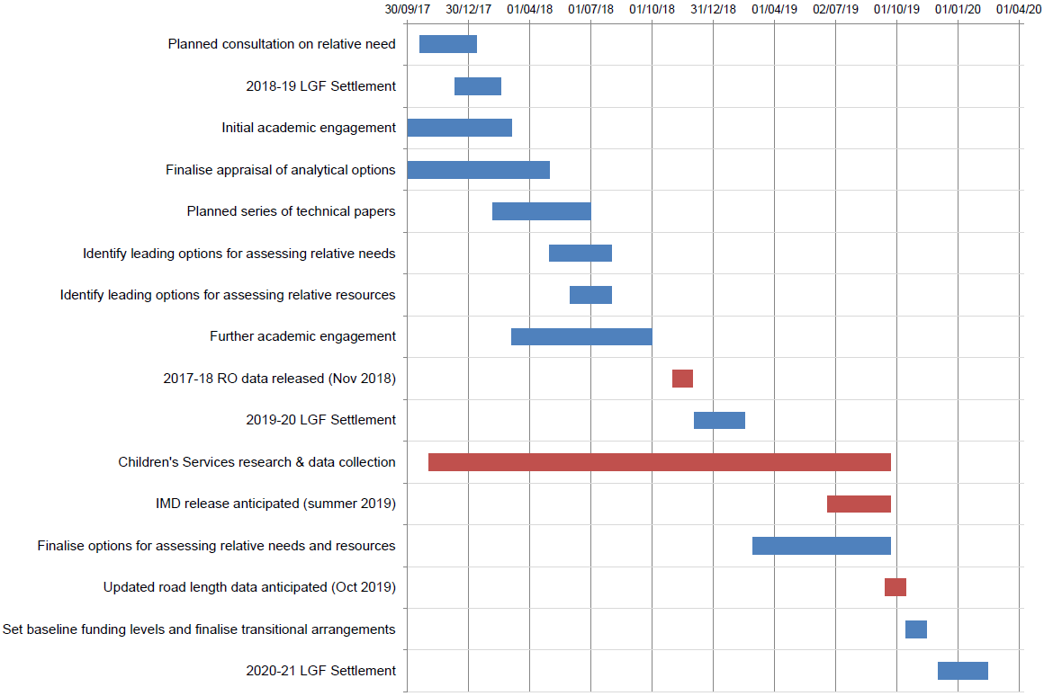
APPENDIX B – DCLG Fair Funding Review Draft Timeline

Appendix C - Proposed additional work on the Fair Funding Review
Project | Purpose and description | In-house or commissioned?
Key criteria for assessing proposed distribution models and methodologies | To give the LGA a structured and consistent way to assess new distribution models. | In-house with the support of the Task and Finish Group, Leadership Board and Executive
Damping/transition mechanisms | An analysis of historic damping / transition mechanisms and a model to inform discussions on the guiding principles of transition. To inform LGA and member authorities’ policy. | Consider commissioning
Council tax equalisation | A model to identify the impact of adjustments for council tax and council tax support on individual authorities.  To inform LGA policy and to help individual member councils evaluate DCLG proposals. | Consider commissioning
Distribution model: develop a distribution model | A model to allow local authorities to see the impact of different key cost drivers and differential weightings. To help the LGA and member councils evaluate the impact of various Government and stakeholder proposals on their council and to allow them to put forward their own proposals | Consider commissioning
Distribution model: update the data | Update the data in the current distribution model (where updated data is available) to see the impact of this on individual allocations separate to any methodology changes. In effect this would provide an updated baseline to inform a discussion on how long the formulae remain ‘future proof’ without any review of weightings.  To help the LGA and member authorities form policy on the frequency of distribution resets, or other ways to ‘future proof’ the mechanism. | Consider commissioning

