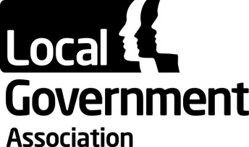

Fire Commission – Terms of Reference

The Fire Commission shall provide the forum within the LGA for all Fire and Rescue services throughout England and Wales. The Fire Commission will act in a way that complements the principles and corporate priorities of the LGA as a whole.

The purpose of the Commission shall be to:

- Provide the forum in which fire authorities can discuss matters of common concern and exchange good practice and experience.
- Discuss in-depth policies and issues and feed in views to the Fire Services Management Committee, so that the Fire Services Management Committee can take into account the needs, priorities and aspirations of all fire authorities in formulating and promoting its policies.
- Assist in promoting the role and interests of fire authorities and the ability of those authorities to meet the needs of the communities they serve.

The Commission will achieve these objectives by:

- Bringing together representatives of fire authorities four times a year and arranging other meetings, conferences and seminars as appropriate.
- Working closely with the LGA's Fire Services Management Committee to inform their decisions.
- Appointing representatives to work on sector specific campaigns, task and finish groups, and projects identified by members.

Quorum

One third of the members, provided that representatives of at least 2 political groups represented on the body are present.

Political Composition

Conservative group: 39 members
Labour group: 32 members
Independent group: 8 members
Liberal Democrat group: 10 members

Substitute members from each political group may also be appointed.

Frequency per year

Two meetings to be held annually.

Reporting Accountabilities

The Fire Commission is led by the Fire Services Management Committee, which reports to the Safer & Stronger Communities Board.

